Customer Engagement & Product Utilization Analytics for Retention Strategy
(A Behavioural and Relationship-Strength Approach to Bank Customer Churn)

Research Paper
- Prepared for: Unified Mentor
- Prepared by: Tisha
- Dataset Used: European_Bank.csv — 10,000 customer records

CONTENTS

SL NO | CHAPTERS | PAGE NUMBER
1 | Abstract | 1
2 | Background and context  - Problem statement  - Objectives  - Primary  - Secondary | 1
3 | Dataset Description | 2
4 | Analytical Methodology  - Data Ingestion & Validation  - Engagement Classification  - Product Utilization Analysis  - Financial Commitment vs. Engagement Analysis  - Retention Strength Assessment | 3
5 | Findings  - Engagement Drives Churn More Than Product Count Alone  - Product Depth Has a Non-Linear, Not Purely Positive, Effect on Retention  - Activity Status Is the Strongest Behavioral Predictor  - At-Risk Premium Customers Represent Meaningful Silent-Churn Exposure  - Relationship Strength Index Outperforms Any Single Factor  - Geographic and Demographic Context | 4-9
6 | Key Performance Indicators | 10
7 | Discussion and Strategic Insights | 10
8 | Recommendations | 11
9 | Conclusion | 11

Abstract

Customer churn in retail banking is routinely modelled using demographic and financial characteristics, but these signals frequently fail to explain why financially sound clients continue to depart. This study examines 10,000 customer records from a European retail bank to see whether engagement and product-relationship depth, rather than balance or salary, better explain attrition. Using engagement segmentation, product utilization analysis, and a composite Relationship Strength Index (RSI), the analysis discovers that activity status and product count interact non-linearly with churn: single-product and over-leveraged (3-4 product) customers churn far more than customers holding exactly two products, and inactive high-balance customers churn nearly three times as fast as engaged customers. These findings encourage a move away from demographic-based retention strategies and toward engagement-driven, product-mix-aware treatments.

1. Background and Context

Banks are increasingly recognizing that long-term retention is determined by customer behaviour and engagement rather than demographics alone. Customers may appear financially secure, with a large balance or salary, yet they nonetheless churn due to low engagement, restricted product adoption, or a weak relationship depth with the bank. Understanding how customers utilize banking products and services is critical for developing effective cross-selling tactics, loyalty programs, and engagement-based retention activities. This project, commissioned as part of the Unified Mentor program in collaboration with the European Central Bank, assesses retention using the lens of customer behaviour and relationship strength.

1.1 Problem Statement

Despite having data on client engagement and product usage, banks frequently lack quantitative insight into which behaviour’s drive retention, clarity on whether product depth decreases turnover, and proof that high balances alone secure loyalty. As a result, retention methods are typically general and do not reflect actual customer behaviour.

1.2 Objectives

Primary objectives:
● Analyse the correlation between engagement and churn
● Measure the retention effect of product volume and product mix
● Identify high-value but disengaged customers
Secondary objectives:
● Support engagement-driven retention strategies
● Enhance product bundling decisions
● Reduce silent churn of premium customers

2. Dataset Description

The data set contains 10,000 records of customers with 14 fields each related to demographic, financial and behavioural attributes. All binary fields (HasCrCard, IsActiveMember, Exited) had only 0/1 values. It was checked that Geography contained France, Spain and Germany. No structural inconsistencies or missing values were found during the validation process.

Column | Description
Customer Id | Unique customer identifier
Surname | Customer surname
Credit Score | Customer creditworthiness
Geography | France, Spain, Germany
Gender | Male / Female
Age | Customer age
Tenure | Years with the bank
Balance | Account balance
Num Of Products | Number of bank products held
HasCrCard | Credit card ownership
IsActiveMember | Activity indicator
Estimated Salary | Estimated annual salary
Exited | Churn indicator (target)
Overall churn rate: 20.37% (2,037 of 10,000 customers exited).

3. Analytical Methodology

3.1 Data Ingestion & Validation
Data set was imported and checked for completeness, consistency of binary fields and accuracy of churn labels. There were no records to delete.

3.2 Engagement Classification
To create four engagement profiles, we combined customer's activity status, number of products and balance tier:

- Active Engaged – a member who is actively engaged with 2 or more products
- Active but Low-Product – an active member with only one product
- Inactive Disengaged — inactive member with balance below top quartile
- High-Balance Inactive – an inactive member with a balance in the top quartile (≥ 75th percentile).

3.3 Product Utilization Analysis
The churn was measured for single product holders vs. multi product holders and product counts from 1 to 4.

3.4 Financial Commitment vs. Engagement Analysis
Cross-analysis of balance and activity status was performed to identify salary–balance mismatches and to identify at-risk premium customers, defined as inactive members with matching balances in the top quartile.

3.5 Retention Strength Assessment

To check if the combined depth of relationships is a better predictor of retention than any individual factor, a composite Relationship Strength Index (RSI) was derived by combining the activity status, product count and credit card ownership with weights of 0.4, 0.4 and 0.2 respectively.

4. Findings

4.1 Engagement Drives Churn More Than Product Count Alone

Figure 1: Churn rate 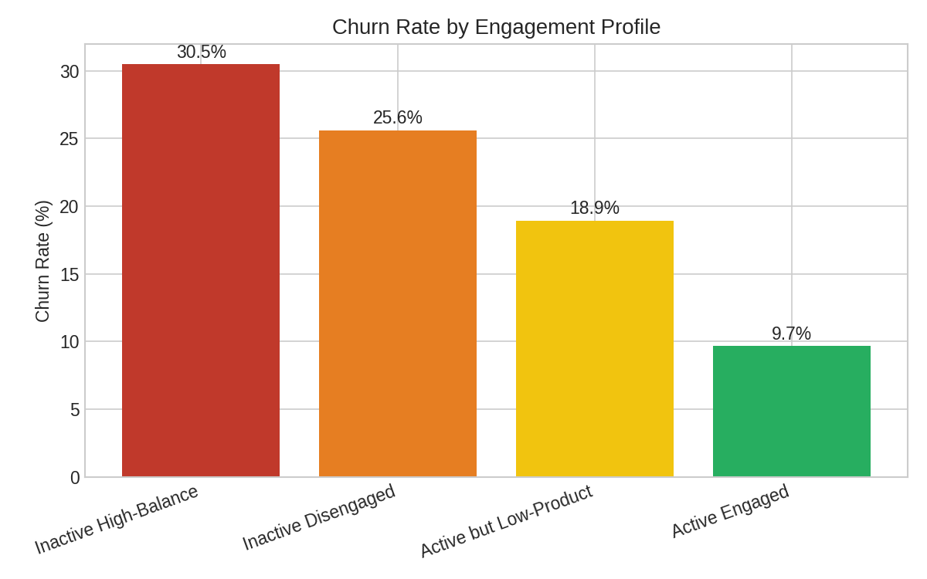by engagement profile

The churn rate of Active Engaged customers is only 9.7% and the churn rates of Inactive Disengaged customers and Inactive High-Balance customers are 25.6% and 30.5% respectively. This difference is more than three times the difference for Inactive Disengaged customers and is primarily driven by activity status rather than wealth.

4.2 Product Depth Has a Non-Linear, Not Purely Positive, Effect on Retention

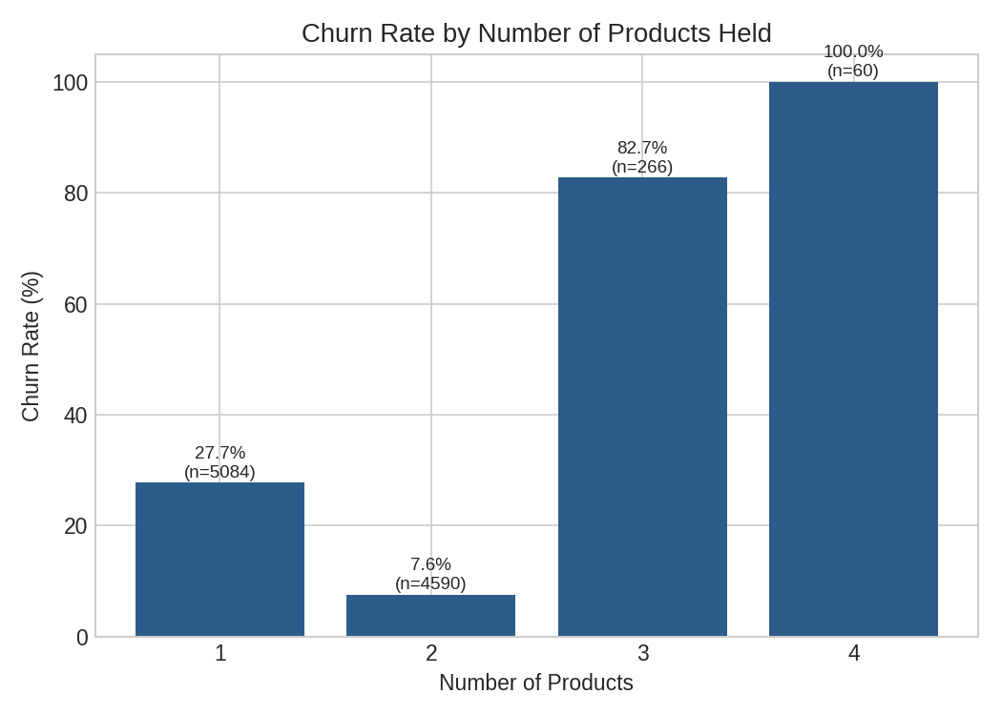
Figure 2: Churn rate by number of products held

Product depth is moderately strong, supporting the relationship with the lowest churn (7.6%) for customers with exactly two products. However, the churn rate is much higher for customers with three products (82.7%) and is 100% for the small number of customers with four products. This data set directly contradicts the assumption that “more products always mean more loyalty.” It suggests that over-concentration in 3-4 products is a distinct high-risk segment, not simply cross-sell success, and deserves further investigation as to whether these accounts are indicative of forced bundling, dissatisfaction after a failed multi-product relationship, or a life-stage/attrition pattern (this group also skews older, with an average age of ~43-46 vs. 38 for 1-2 product holders).
Single product customers churn at 27.7% vs. 12.8% for multi-product (2+) customers. This difference indicates the significance of product depth but the relationship peaks at two products rather than increasing indefinitely.

4.3 Activity Status Is the Strongest Behavioural Predictor

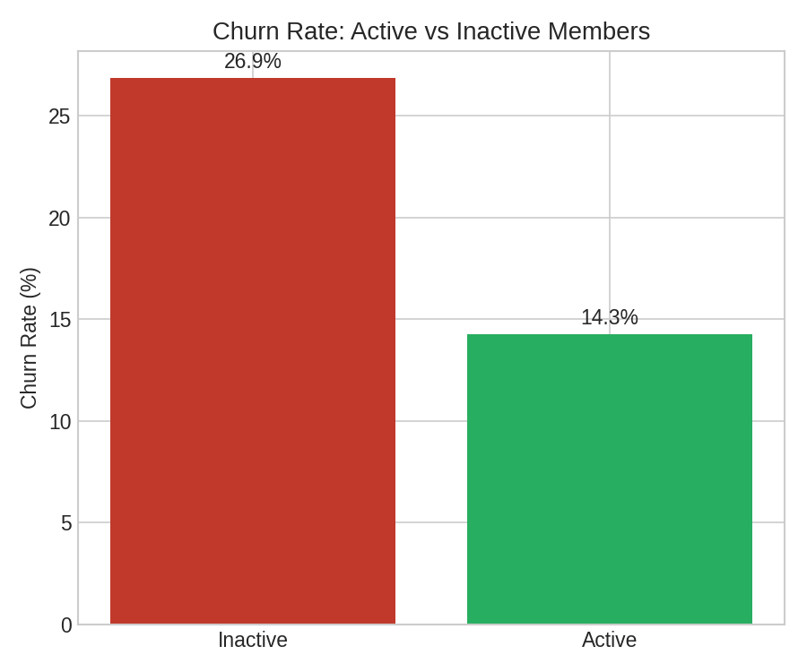
Figure 3: Churn rate — active vs. inactive members

Inactive members churn at 26.9% compared to 14.3% for active members. Interestingly, the average balance across both groups is almost the same (₹77,134 inactive vs ₹75,875 active). This corroborates the fact that balance is not a proxy for engagement or loyalty – an echo of the project’s underlying hypothesis.

4.4 At-Risk Premium Customers Represent Meaningful Silent-Churn Exposure

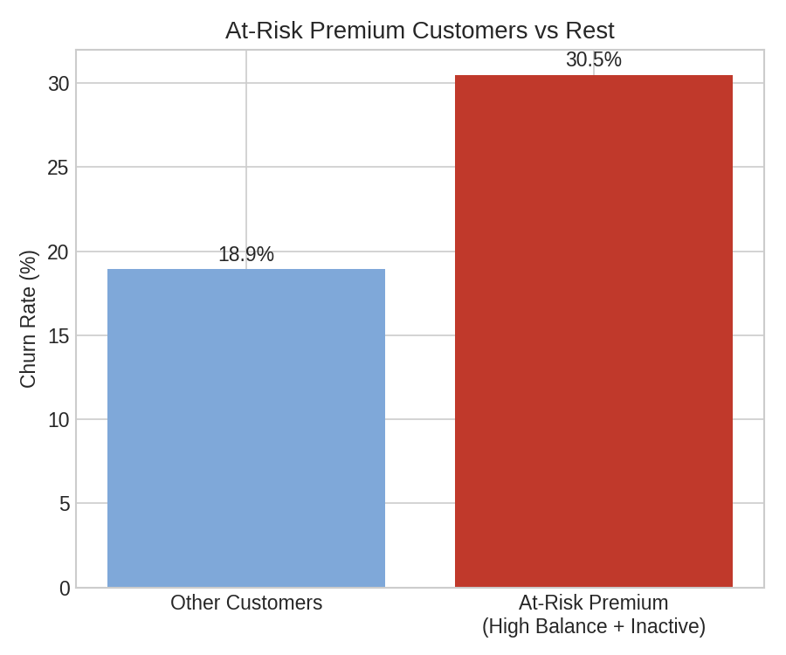
Figure 4: At-risk premium customers vs. remaining base

The “at-risk premium” segment consists of 1,247 customers (12.5% of the base) that are inactive members with top-quartile balance. Their churn rate (30.5%) is 1.6x the rest of the base (18.9%) and is the clearest silent-churn signal in the dataset: high-value customers that look safe on a balance sheet but are behaviourally disengaged.

4.5 Relationship Strength Index Outperforms Any Single Factor

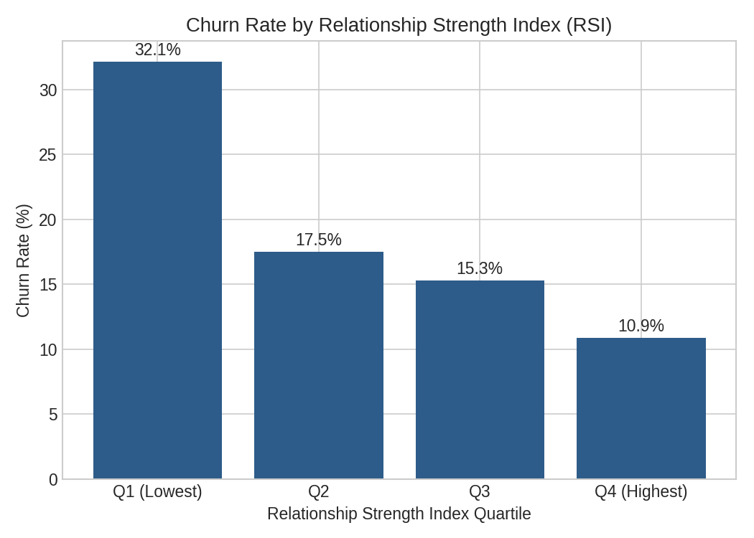
Figure 5: Churn rate by Relationship Strength Index (RSI) quartile

Churn decreases monotonically and steadily across RSI quartiles, from 32.1% in the lowest to 10.9% in the highest — a cleaner, more monotonic gradient than any individual variable, including product count alone. This provides support for the idea of using a composite relationship score, rather than any one field, as the basis of retention scoring.

4.6 Geographic and Demographic Context

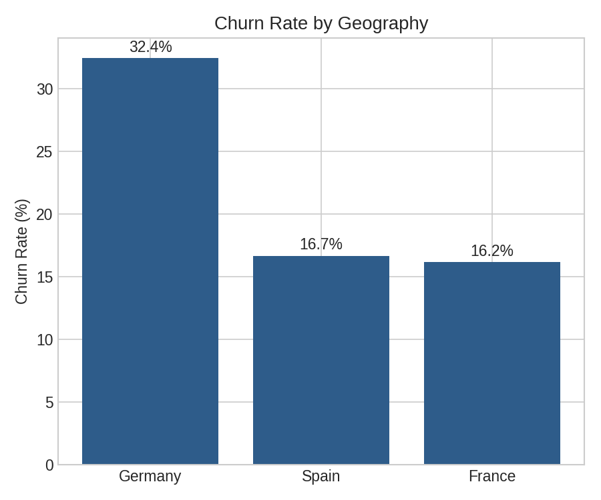
Figure 6: Churn rate by geography

Although product and engagement distributions are similar across the three countries, churn is much higher in Germany (32.4%) than in France (16.2%) and Spain (16.7%). This shows that the behavioural factors previously identified are magnified by market-specific factors (competition, service quality or local alternatives). The churn rate for female customers is higher than for male customers (25.1% vs. 16.5%). The churn propensity also increases with age (correlation +0.29) as older customers are more likely to have 3-4 products and also more likely to churn. This also supports the observation in Section 4.2 that the 3-4 product demographic may represent an older, potentially over-sold or discontented group, rather than a fruitful cross-selling achievement.

5. Key Performance Indicators

KPI | Definition | Result | Interpretation
Engagement Retention Ratio | Inactive churn rate ÷ Active churn rate | 1.88x | Inactive members are nearly twice as likely to churn as active members
Product Depth Index | Correlation of product count with retention | +0.048 (weak, non-linear) | Product count alone is a weak linear predictor; the true relationship peaks at 2 products
High-Balance Disengagement Rate | Share of top-quartile-balance customers who are inactive | 49.9% | Roughly half of premium-balance customers are behaviourally disengaged
Credit Card Stickiness Score | Non-card churn rate minus card-holder churn rate | +0.6 pts (negligible) | Card ownership shows almost no standalone retention effect in this dataset
Relationship Strength Index | Composite of activity, product count, and card ownership | Corr. −0.153; monotonic across quartiles | Best single composite predictor of retention identified in this analysis

6. Discussion and Strategic Insights

- Compensation and remuneration are poor sole indicators of loyalty – the sensitive premium segment proves that high value clients can be subtly alienated.
- Two offerings seem to be the best threshold of retention. Rather than increasing the number of products indiscriminately, the bank should investigate the shift from two to three products.
- The 3-4 product segment is small (326 customers) but has high churn and should be treated as a separate, high-priority investigation group – more suited to relationship-manager engagement than cross-selling.
- The most powerful retention strategy is activity re-engagement, not new product sales, because of the size of the Engagement Retention Ratio.
- Apart from the behavioural segmentation, the high turnover rate in Germany requires a comprehensive market analysis.

7. Recommendations

- Implement the at-risk premium segment (1,247 clients) as a proactive outreach program by relationship managers, prioritized by account balance.
- Before pushing more product bundling as a retention strategy, take a look at the 3-4 product cohort directly (e.g. customer interviews, complaints logs, etc.).
- Shift retention key performance indicators away from account initiation and product quantity goals to engagement and activity metrics, using the Relationship Strength Index as an ongoing retention metric.
- Launch a re-engagement campaign (separate from a cross-selling campaign) targeted at the “Active but Low-Product” and “Inactive Disengaged” segments, which together make up more than 60% of the customer base.
- Perform a Germany-specific retention analysis to separate out market-level influences from the behavioural factors identified herein.

8. Conclusion

This analysis moves the focus of customer churn from a purely demographic one to a behavioural and relationship-strength one. Engagement status, product-mix depth, and a composite relationship strength score all trump balance or salary as retention indicators, and importantly, expose a segment of high-value, disengaged customers invisible to demographic-only churn models. A more actionable way to reduce churn is to deploy a strategy of engagement-driven retention, based on the Relationship Strength Index and the at-risk premium and over-leveraged product segments identified here, instead of demographic targeting alone.

